**FAZAIA BILQUIS COLLEGE OF EDUCATION FOR WOMEN**

**PAF Nur Khan, Rawalpindi**

**Lab Task Spring 2024**

**Subject Name:** Artificial Intelligence Lab **Teacher Name:** Ms. Mehwish

**Program:** BSCS  **Semester:** 6th **Section: A** **Lab Task**:1+ 2

**Name:** Ibadat Ali **Roll no:** 64

**Lab 1**

**What is the history of AI?**

The history of Artificial Intelligence (AI) dates back to the mid-20th century, with the invention of the first digital computers in the 1940s. Since then, AI has evolved rapidly and become an integral part of our daily lives. The first AI system, the Theseus, was built by Claude Shannon in 1950 and was a remote-controlled mouse that could find its way out of a labyrinth. In the following decades, AI systems have become increasingly sophisticated, with the ability to recognize handwriting, understand language, and generate images.

In the past two decades, AI development has accelerated, with AI systems becoming capable of performing tasks previously thought to be the exclusive domain of humans. For example, AI systems can now provide language and image recognition at a human level, and can even generate photorealistic images based on text prompts. AI systems have also entered various aspects of our daily lives, from auto-completing emails to assisting pilots in flying planes.

The rapid advances in AI capabilities have been driven by increases in training computation, algorithms, and input data used for training. As training computation has increased, AI systems have become more powerful, with the ability to perform increasingly complex tasks. The exponential growth in training computation has accelerated since 2010, with a doubling time of just 6 months.

AI researchers study long-term trends in AI development to predict what is possible in the future. According to a study by AI researcher Ajeya Cotra, there is a 50% probability that "transformative AI" will be developed by the year 2040, which would match the capabilities of a human brain.

**What are the applications of Ai?**

* Google Cloud platform
* Chat GPT
* ELSA
* Face app
* Lensa
* Starryaii
* Google map
* Duolingo
* Snapchat
* Google assistant
* Amazon Alexa
* Microsoft Copilot

**Lab 2**

**Write at least two applications of Artificial Intelligence that are used in data security field and entertainment field (2 applications for each field).**

1. **Data Security Field:**

**AI-Driven Threat Detection and Response:**

Application: AI is used to continuously monitor network traffic, system logs, and user behaviors to detect potential security threats and respond to them in real-time.

How it Works: Machine learning looks at data patterns to find unusual things that might mean something bad is happening in security. AI systems can then figure out how serious it is and do things like putting problem systems in isolation, stopping suspicious internet traffic, or telling security people to check it out more.

**Behavioral Biometrics for Authentication:**

Application: AI-powered behavioral biometrics are utilized for user authentication, leveraging unique behavioral patterns to enhance security.

How it Works: By analyzing factors like typing rhythm, mouse movements, and touchscreen gestures, AI algorithms create user profiles and continuously authenticate users based on their behavioral characteristics. This provides a more secure and user-friendly alternative to traditional authentication methods like passwords or PINs.

1. **Entertainment Field:**

**Personalized Content Recommendations:**

Application: AI is used to analyze user preferences, viewing habits, and demographic data to recommend personalized content such as movies, music, or games.

How it Works: By employing machine learning algorithms, entertainment platforms can predict user preferences and tailor content recommendations accordingly. AI continuously learns from user interactions to refine recommendations over time, enhancing user satisfaction and engagement.

**AI-Generated Content Creation:**

Application: AI is employed to generate original content, including music, artwork, and stories, to entertain audiences.

How it Works: Smart computer programs like deep learning can make new things like music, art, or stories by learning from what already exists. For instance, AI can create its own songs, make pictures, or write stories all on its own. This lets artists try out new ideas and make their work in different ways.

**Write the name of any application that uses A.I. in your daily use & explain how (2-3 lines)?**

**Blackbox** is a tool of Ai that I use mostly to help me generate sample codes for my projects and to help me find the issues with my code that it is not providing the desired output.

**Write a python program to print the multiplication table for the number given by user?**

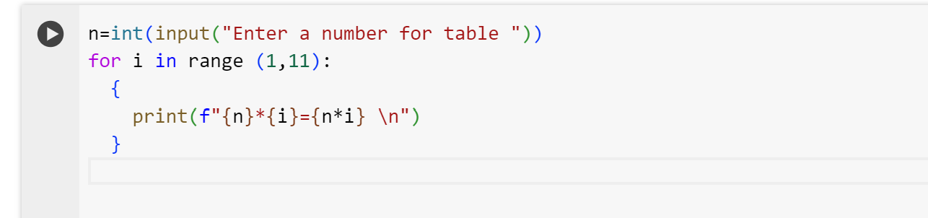

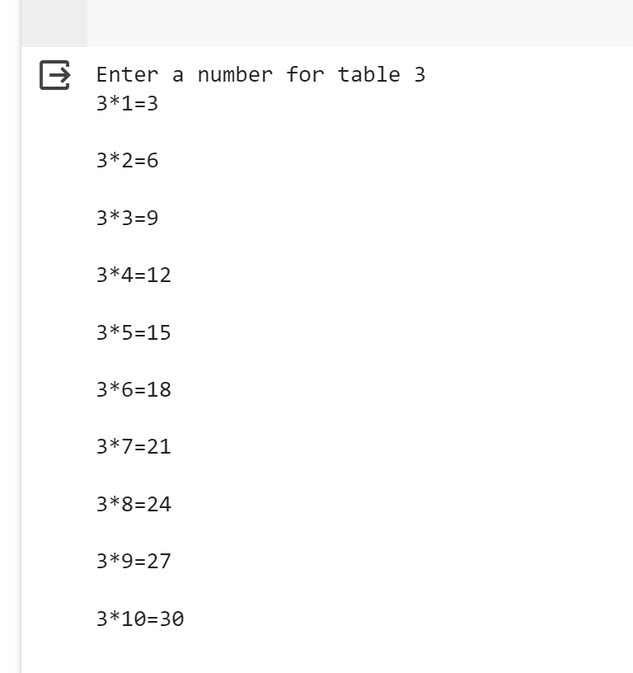

**Write a python program using function to check whether the given number is prime or not?**

